Отчет о результатах тестирования

Web-приложения

«Belhard Academy Schedule Planning»

**Оглавление**

1.Краткое описание……………………………………………………

2. Описание процесса тестирования……………………………………….

3. Статистика по дефектам………………………………………………….

4. Список дефектов…………………………………………………………

Рекомендации…………………………………………………………….

Приложение………………………………………………………………….

**1.      Краткое описание:**

В период с 16.08.22 по 30.09.22 командой тестировщиков (см. таблицу 1) были проведены следующие работы:

- тестирование требований, представленных в «Vision and Scope document for Belhard Academy Schedule Planning System Version 1.0» и figma.com, оформление замечаний и предложений по результатам тестирования требований, предоставление замечаний разработчикам для корректировки;

- составление тест-кейсов по требованиям с использованием ресурса belhard-academy.testcaselab.com;

- составление тест-кейсов по тестированию API на основе предоставленной разработчиками документации Swagger API с использованием инструмента тестирования Postman;

- составление тест-кейсов для тестирования приложения с использованием ресурса belhard-academy. testcaselab.com;

- выполнение тест-кейсов с оформлением баг-репортов на ресурсе app.clickup.com;

- предоставление баг-репортов разработчикам для устранения или отклонения.

 Таблица 1

|  |  |  |  |
| --- | --- | --- | --- |
| **Имя** | **Модули приложения** | **Используемое устройство** | **ОС** |
| **Группа А** |  |  |  |
| Алексей Калмыков | Teachers  Locations  Classroms |  |  |
| Игорь Кулик | Dell Inspiron 17 5000 Series | Win 10 x64  Google Chrome version 106.0.5249.91 |
| Екатерина Нестерович | VivoBook_ASUS  Laptop X513EAN_X513EA | Windows 10 Pro |
| **Группа Б** |  |  |  |
| Евгений Рачинский | Schedule  Registration |  |  |
| Виктория Сукалина |  |  |
| Игорь Горин |  |  |
| **Группа В** |  |  |  |
| Надежда Тарасевич | Authorization  Courses |  |  |
| Виктория Хотянович |  |  |
| Илья Ярошевич |  |  |
| Сергей Дударев |  |  |

**2.  Описание процесса тестирования**

На этапе процесса тестирования требований были внесены изменения в «Vision and Scope document for Belhard Academy Schedule Planning System Version 1.0».

Команда тестировщиков была разделена на три подгруппы с назначением каждой подгруппе модулей для тестирования (см. таблицу 1).

Тестирование проводилось вручную с использованием устройств и операционных систем указанных в таблице 1.

Были проведены  Test Runs (см. таблицу 2 и диаграмму 1).

 Таблица 2

|  |  |  |  |  |
| --- | --- | --- | --- | --- |
| Наименование Test Runs | Ссылка | Количество тестов | Оформлено баг-репортов | Исправлено дефектов |
| Verify GET methods | <https://belhard-academy.testcaselab.com/projects/BLH/test_run/61690?sort_dir=desc&sort_attr=created_at&test_case_id=1349703> | 89 (14 - failed,  10 - blocked,  65 - passed) | 0 | 0 |
| Testing from the UI side | <https://belhard-academy.testcaselab.com/projects/BLH/test_run/62175?sort_dir=desc&sort_attr=created_at&test_case_id=1351925> | 238  (66 - failed,  27 - blocked,  144 - passed) | 63 | в работе |

**Диаграмма 1**: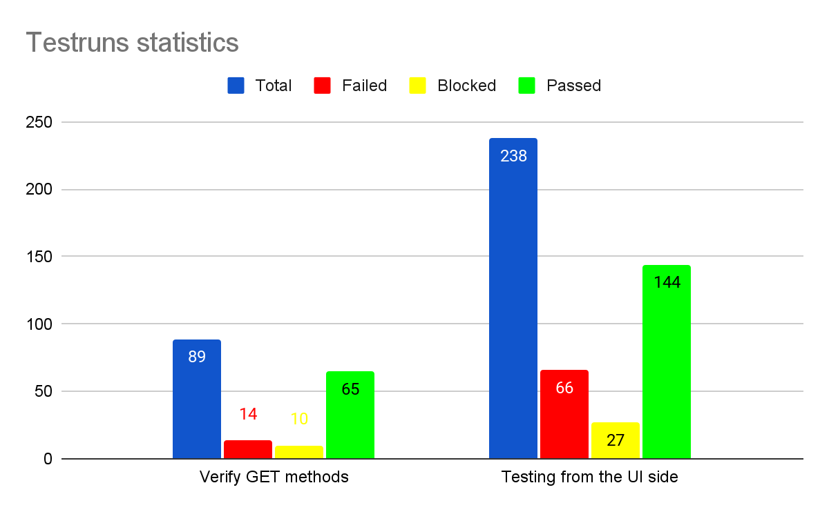

|  |  |  |  |  |  |
| --- | --- | --- | --- | --- | --- |
|  |  | **Priority** | | | |
| **Status** | **Количество** | **Law** | **Normal** | **High** | **Urgent** |
| Found | 63 | 8 | 46 | 7 | 2 |
| TO DO | 7 | 0 | 5 | 0 | 2 |
| IN PROGRESS | 0 | 0 | 0 | 0 | 0 |
| READY FOR TESTING | 11 | 0 | 7 | 4 | 0 |
| IN TESTING | 11 | 0 | 3 | 3 | 0 |
| COMPLETE | 45 | 8 | 31 | 0 | 0 |

**General list of defects**

|  |  |  |  |
| --- | --- | --- | --- |
| **Id** | **Priority** | **Description** | **Test Link** |
|  | Normal | Registration with email consisting of more than 64 symbols |  |
|  | Urgent | Registration is passed with different data "Password" and "Repeat password" |  |
|  | Normal | Registration. Password write with pressed key [Caps-Lock] |  |
| BLH-9 | Normal | Registration with valid data, Password write with pressed key [Caps-Lock](No alerts anywhere) | <https://belhard-academy.testcaselab.com/projects/BLH/test_run/62175?text=BLH-9> |
| BLH-3 | Urgent | Registration with valid data, email write with pressed key [Caps-Lock] | <https://belhard-academy.testcaselab.com/projects/BLH/test_run/62175?text=BLH-3> |
|  | Normal | Registration with invalid e-mail (domain part consist only of digits) |  |
| BLH-772 | Normal | Registration with invalid e-mail (domain part consist only of digits) | <https://belhard-academy.testcaselab.com/projects/BLH/test_run/62175?text=BLH-772> |
| BLH-803 | Normal | We can't edit course from the course schedule page | <https://belhard-academy.testcaselab.com/projects/BLH/test_run/62175?text=BLH-803> |
| BLH-40 | Normal | Courses. Inability to create a course with two teachers | <https://belhard-academy.testcaselab.com/projects/BLH/test_run/62175?text=BLH-40> |
| BLH-800 | High | We can't delete course from the course schedule page | <https://belhard-academy.testcaselab.com/projects/BLH/test_run/62175?text=BLH-800> |
| BLH-20 | High | Teachers. Delete. Entry with deleted teacher does not change color. Super administrator. | <https://belhard-academy.testcaselab.com/projects/BLH/test_run/62175?text=BLH-20> |
| BLH-779 | High | Teachers. Add. There is no alert "Field is required" during creating with empty "Name" field | <https://belhard-academy.testcaselab.com/projects/BLH/test_run/62175?text=BLH-779> |
| BLH-778 | High | Teachers. Add. There is no alert "Field is required" during creating with empty "Surname" field | <https://belhard-academy.testcaselab.com/projects/BLH/test_run/62175?text=BLH-778> |
| BLH-706 | Normal | Teachers. Delete. No warning message when delete a teacher with manager permissions. | <https://belhard-academy.testcaselab.com/projects/BLH/test_run/62175?text=BLH-706> |
| BLH-705 | Normal | Teachers. Delete. No warning message when delete a teacher with administrator permissions. | <https://belhard-academy.testcaselab.com/projects/BLH/test_run/62175?text=BLH-705> |
| BLH-5 | Normal | Teachers. Add. Messages about required fields does not appear when the fields are empty. Super administrator. | <https://belhard-academy.testcaselab.com/projects/BLH/test_run/62175?text=BLH-5> |
|  | High | Courses. Create. Error "IntegrityError at /courses/new/" when creating a course with valid data. (Course created) | <https://belhard-academy.testcaselab.com/projects/BLH/test_run/62175?sort_dir=desc&sort_attr=created_at&test_case_id=1347384&category_id=164642> |
| BLH-807 | Normal | We can't see comments from the course schedule page | <https://belhard-academy.testcaselab.com/projects/BLH/test_run/62175?text=BLH-807> |
|  | High | Courses. Create. Error "IndexError at /courses/new/" when creating a course with valid data. (Course created) | <https://belhard-academy.testcaselab.com/projects/BLH/test_run/62175?sort_dir=desc&sort_attr=created_at&test_case_id=1351950&category_id=164642> |
|  | High | Courses. Create. Error "DoesNotExist at /courses/new/" when creating a course with valid data. (Course created) | <https://belhard-academy.testcaselab.com/projects/BLH/test_run/62175?sort_dir=desc&sort_attr=created_at&test_case_id=1351951&category_id=164642> |
| BLH-721 | Normal | Locations. Location is deleted from DB during deleting from the UI side | <https://belhard-academy.testcaselab.com/projects/BLH/test_run/62175?text=BLH-721> |
| BLH-762 | Normal | Locations. Classroom. View classroom. Classroom is deleted from DB during deleting from the UI side | <https://belhard-academy.testcaselab.com/projects/BLH/test_run/62175?text=BLH-762> |
| BLH-89 | Normal | Locations. View location. Location is deleted from DB during deleting from the UI side | <https://belhard-academy.testcaselab.com/projects/BLH/test_run/62175?text=BLH-89> |
| BLH-761 | High | Locations. Classroom. Classroom is deleted from DB during deleting from the UI side | <https://belhard-academy.testcaselab.com/projects/BLH/test_run/62175?text=BLH-761> |
| BLH-719 | Normal | Locations. The location updated from administrator permissions | <https://belhard-academy.testcaselab.com/projects/BLH/test_run/62175?text=BLH-719> |
| BLH-686 | Normal | Locations. The location created from administrator permissions | <https://belhard-academy.testcaselab.com/projects/BLH/test_run/62175?text=BLH-686> |
| BLH-693 | Normal | Locations. The location opened for view from administrator permissions | <https://belhard-academy.testcaselab.com/projects/BLH/test_run/62175?text=BLH-693> |
| BLH-724 | Normal | Locations. The location deleted from administrator permissions | <https://belhard-academy.testcaselab.com/projects/BLH/test_run/62175?text=BLH-724> |
| BLH-764 | Normal | Locations. Classroom. The classroom deleted from administrator permissions | <https://belhard-academy.testcaselab.com/projects/BLH/test_run/62175?text=BLH-764> |
| BLH-759 | Normal | Locations. Classroom. The classroom updated from administrator permissions | <https://belhard-academy.testcaselab.com/projects/BLH/test_run/62175?text=BLH-759> |
| BLH-742 | Normal | Locations. Classroom. The classroom created from administrator permissions | <https://belhard-academy.testcaselab.com/projects/BLH/test_run/62175?text=BLH-742> |
| BLH-745 | Normal | Locations. Classroom. The classroom opened for view from administrator permissions | <https://belhard-academy.testcaselab.com/projects/BLH/test_run/62175?text=BLH-745> |
| BLH-720 | Normal | Locations. The location updated from manager permissions | <https://belhard-academy.testcaselab.com/projects/BLH/test_run/62175?text=BLH-720> |
| BLH-725 | Normal | Locations. The location deleted from manager permissions | <https://belhard-academy.testcaselab.com/projects/BLH/test_run/62175?text=BLH-725> |
| BLH-694 | Normal | Locations. The location opened for view from manager permissions | <https://belhard-academy.testcaselab.com/projects/BLH/test_run/62175?text=BLH-694> |
| BLH-760 | Normal | Locations. Classroom. The classroom updated from manager permissions | <https://belhard-academy.testcaselab.com/projects/BLH/test_run/62175?text=BLH-760> |
| BLH-746 | Normal | Locations. Classroom. The classroom opened for view from manager permissions | <https://belhard-academy.testcaselab.com/projects/BLH/test_run/62175?text=BLH-746> |
| BLH-765 | Normal | Locations. Classroom. The classroom deleted from manager permissions | <https://belhard-academy.testcaselab.com/projects/BLH/test_run/62175?text=BLH-765> |
| BLH-743 | Normal | Locations. Classroom. The classroom created from manager permissions | <https://belhard-academy.testcaselab.com/projects/BLH/test_run/62175?text=BLH-743> |
| BLH-687 | Normal | Locations. The location created from manager permissions | <https://belhard-academy.testcaselab.com/projects/BLH/test_run/62175?text=BLH-687> |
| BLH-682 | Normal | Locations. Create location. Created copy of one location | <https://belhard-academy.testcaselab.com/projects/BLH/test_run/62175?text=BLH-682> |
| BLH-126 | Normal | Locations. Create location. The location created with Latin alphabet in the "City" field | <https://belhard-academy.testcaselab.com/projects/BLH/test_run/62175?text=BLH-126> |
| BLH-712 | Normal | Locations. Update location. The location updated with Latin alphabet in the "Building" field | <https://belhard-academy.testcaselab.com/projects/BLH/test_run/62175?text=BLH-712> |
| BLH-738 | Normal | Locations. Classroom. The "Classroom" created with only 10 symbols in the "Classroom" field | <https://belhard-academy.testcaselab.com/projects/BLH/test_run/62175?text=BLH-738> |
| BLH-718 | Normal | Locations. Update location. The location updated with XSS injection in the "Street" field | <https://belhard-academy.testcaselab.com/projects/BLH/test_run/62175?text=BLH-718> |
| BLH-753 |  | Locations. Classroom. The "Classroom" field is automatically cut excess symbols when the classroom updating. | <https://belhard-academy.testcaselab.com/projects/BLH/test_run/62175?text=BLH-753> |
| BLH-755 | Normal | Locations. Classroom. The classroom updated with only 10 symbols in the "Classroom" field | <https://belhard-academy.testcaselab.com/projects/BLH/test_run/62175?text=BLH-755> |
| BLH-737 | Normal | Locations. Classroom. The classroom updated with Latin alphabet in the "Classroom" field | <https://belhard-academy.testcaselab.com/projects/BLH/test_run/62175?text=BLH-737> |
| BLH-717 | Normal | Locations. Update location. The location updated with XSS injection in the "City" field | <https://belhard-academy.testcaselab.com/projects/BLH/test_run/62175?text=BLH-717> |
| BLH-711 | Normal | Locations. Update location. The location updated with Latin alphabet in the "Street" field | <https://belhard-academy.testcaselab.com/projects/BLH/test_run/62175?text=BLH-711> |
| BLH-701 |  | Locations. Update location. The "Building" field is automatically cut excess symbols | <https://belhard-academy.testcaselab.com/projects/BLH/test_run/62175?text=BLH-701> |
| BLH-710 | Normal | Locations. Update location. The location updated with Latin alphabet in the "City" field | <https://belhard-academy.testcaselab.com/projects/BLH/test_run/62175?text=BLH-710> |
| BLH-700 |  | Locations. Update location. The "Street" field is automatically cut excess symbols | <https://belhard-academy.testcaselab.com/projects/BLH/test_run/62175?text=BLH-700> |
| BLH-691 | Normal | Locations. Create location. The location created with XSS injection in the "Street" field | <https://belhard-academy.testcaselab.com/projects/BLH/test_run/62175?text=BLH-690> |
|  |  | Locations. Update location. The "City" field is automatically cut excess symbols | <https://belhard-academy.testcaselab.com/projects/BLH/test_run/62175?text=BLH-691> |
| BLH-685 | Normal | Locations. Create location. The location created with Latin alphabet in the "Building" field | <https://belhard-academy.testcaselab.com/projects/BLH/test_run/62175?text=BLH-685> |
| BLH-125 |  | Locations. Create location. The "Street" field is automatically cut excess symbols | <https://belhard-academy.testcaselab.com/projects/BLH/test_run/62175?text=BLH-125> |
| BLH-127 | Normal | Locations. Create location. The location created with Latin alphabet in the "Street" field | <https://belhard-academy.testcaselab.com/projects/BLH/test_run/62175?text=BLH-127> |
| BLH-736 |  | Locations. Classroom. The 'Classroom" field is automatically cut excess symbols when creating new classroom | <https://belhard-academy.testcaselab.com/projects/BLH/test_run/62175?text=BLH-736> |
| BLH-124 |  | Locations. Create location. The "City" field is automatically cut excess symbols | <https://belhard-academy.testcaselab.com/projects/BLH/test_run/62175?text=BLH-124> |
| BLH-684 |  | Locations. Create location. The "Building" field is automatically cut excess symbols | <https://belhard-academy.testcaselab.com/projects/BLH/test_run/62175?text=BLH-684> |

**Diagram 1:**

